What an incredible term this has been, we have had sixth form pupils out on work experience for the first time in over two and a half years, an incredible sports day, the best prom we have ever had and a sponsored charity walk for Rainbows. More about all of these things later in the newsletter. You will also be aware we finally had our long-awaited Ofsted inspection on the 21st and 22nd June. We found the visit to be positive and supportive and look forward to sharing the report with you. Unfortunately, due to the inspection taking place so late in the academic year, we are unlikely to receive the report until the Autumn term.
Staff News
As we reach the end of another school year we will be saying a very fond farewell to four of our staff team. Congratulations to Navpreet, our fabulous P3 Teacher, who is getting married in the summer and moving out of the area. We also say fond farewells to Sonal who has worked as a Teaching Assistant, Rubina a valued member of our administrative team and Victoria, one of our super mid-day team. We will miss you all and thank you for all you have brought to Nether Hall School.
As we say goodbye and good luck to Navpreet, Sonal, Rubina and Victoria we say hello to Sian, Mikey, Rebekah our three new teachers and Shannon, Beth, Jonathon, Louise and Abibatu who will be joining our incredible team of Teaching Assistants. Welcome to the team!
Outdoor Learning Update
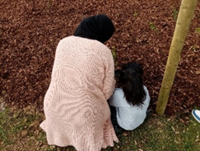
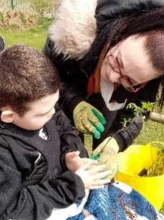
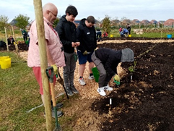
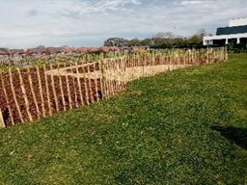
In the last newsletter we reported that we had been selected to have a Tiny Forest planted over the Easter break. This was such an amazing day! We welcomed over sixty people including pupils and their parents, staff and their families, governors and representatives from Severn Trent, Earth Watch and Ground Control who planted an amazing 600 trees in less than 2-hours. The Tiny Forest, planted to offset the carbon footprint of the Commonwealth Games 2022 and representing Tanzania, not only looks amazing but is another valuable teaching resource in our outdoor learning area as we all continue to learn about the importance of trees, nature and looking after our world.

Queens Platinum Jubilee Celebration
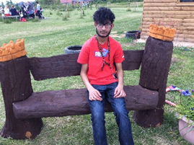
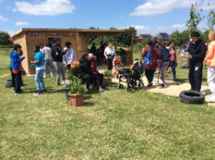
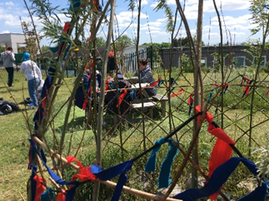
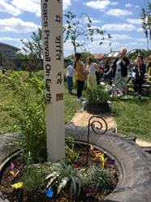
Our lovely field looked wonderful for our Jubilee Party. Decorated with bunting and flags, the field was the perfect venue for a picnic lunch and ice cream as we celebrated Her Majesty’s 70-year reign. Our newly finished sensory garden with its message of Peace on Earth also seemed fitting for the occasion. Vihan is proudly showing off our bespoke Queen’s Bench, complete with golden crowns, which will become a permanent feature of the field after the summer.
Shine Festival
At the time of writing we are still looking forward to our last event of the year, our Shine Festival and keeping our fingers crossed for sunny weather on the last Thursday of term. This year is bigger than ever, with entertainment from 'King Brass', a Mardi Gras band; musicians from Loughborough and Orchard Mead schools; performances from our own ukulele and samba groups, and solos throughout the day!
Sports activities, Zumba, and yoga sessions will also be taking place throughout the day, alongside flower braiding and headdress workshops, henna and glitter tattoo and face-painting.

Work Experience
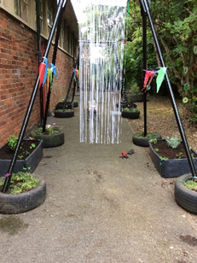
Having written CVs and application letters and attended interviews, a number of our sixth form pupils completed a week of work experience recently. Two students applied for office jobs, four applied to be teaching assistants and five to be gardeners. Our gardeners transformed the spinney at Pindar Road into a wonderful sensory garden complete with its own bug hotel and planting beds for pupils.
We were so proud of all the students. They were polite, incredibly hardworking, flexible and adaptable to change. One of our pupils working in the school office actually took the initial phone call from Ofsted!

Sports Day
How exciting to be able to hold a whole school sports day again this year. The sun shone and the pupils had a brilliant time. Pupils took part in at least 2-track events and there were also 5-field events to ‘have a go’ at. The atmosphere was fantastic, made even more special with the number of parents who came to support, thank you. The pupils did their very best and should be proud of their achievements. Well done to the Yellow team, our overall winners.

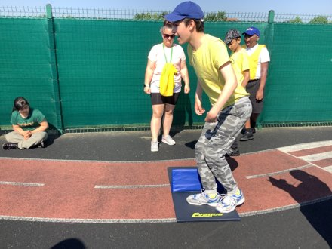
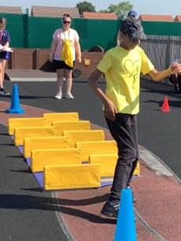
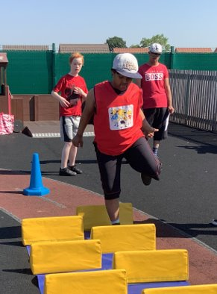

Leaver’s Prom
We were thrilled this year, to be able to have a ‘Proper Prom’ to say goodbye to our leavers. Because the class of 2020 and 2021 missed out on their prom, we invited them back to say hello and goodbye too.
What a brilliant night we had meeting up with old friends, family members and staff who danced the night away in a venue which had plenty of glitter and sparkle, disco beats, a super buffet and an amazing leavers cake. We even had a Hummer turn up which was admired by all.
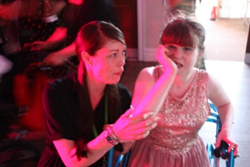
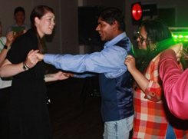
Huge thanks go to Scraptoft Valley Club for the venue and Wayne Betts for his awesome disco both of whom gave their services for free.
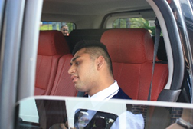

Finally, and most importantly, I know you will want to join me in wishing the 9 pupils leaving school on Friday the very best of luck as they move on from Nether Hall School.
THANK YOU
Together we raised over £1000 for Rainbows through our sponsored walk!

Wishing you and your family a very happy summer.

Sarah Naylor
Head Teacher

